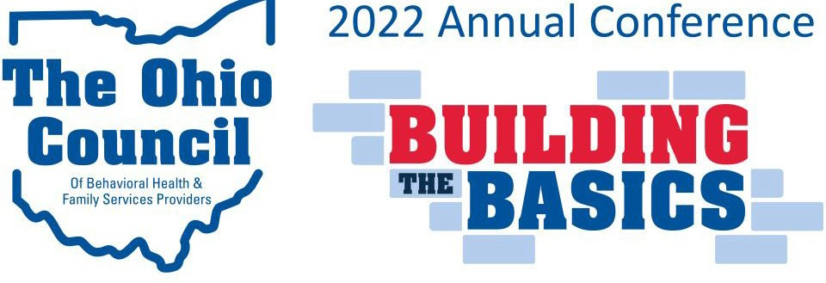

Sponsor the Annual Conference
Thank you for your interest in sponsoring the Annual Conference of The Ohio Council of Behavioral Health & Family Services Providers. The all-virtual 2022 Annual Conference will take place on four Fridays this fall (10/21, 10/28, 11/4, and 11/11). This form will allow you to pick your sponsorship level and start the payment process. Click here to learn more about the event.
Please direct all sponsorship questions to Brenna Whiteside at whiteside@theohiocouncil.org.
Review Our Sponsorship Levels and Benefits

Sponsor Registration Form
"*" indicates required fields

Contact Information
Your Company/Organization*

Sponsorship Contact Name and Title*
The person we should reach out to about your sponsorship.

Sponsorship Contact Email*

Sponsorship Contact Phone*

Sponsorship Level and Billing
Please indicate your company's desired sponsorship level:* Bronze Sponsor: $1,000
Silver Sponsor: $2,500 Gold Sponsor: $5,000
Note: You will receive an invoice for the amount of your sponsorship from quickbooks@notification.intuit.com.

Total
$

Billing Address* Street Address

City
State
Zip

Logo and Marketing Materials
Several sponsorship levels include benefits that will require The Ohio Council to have your company's logo. Please submit it below as a high-quality, print-ready file. Vector artwork is strongly preferred. Questions? Email Administrative Assistant, Brenna Whiteside, whiteside@theohiocouncil.org.

Accepted file types: jpg, png, gif, ai, indd, psd, pdf, Max. file size: 8 MB.

Please email your Sponsor Logo and completed form to whiteside@theohiocouncil.org

